**Introduction to Genetics – Similarities and Differences between Family Members**[1]

**1.** Parents and their biological children have more similar characteristics than unrelated people. Describe what you already know about how genes contribute to the similarities in family members’ characteristics. (If you can, include descriptions of how genes are inherited and how genes influence a person’s characteristics.)

**How do genes influence our characteristics?**

A **gene** is a segment of a DNA molecule that gives the instructions for making a protein.

* Different versions of the same gene are called **alleles**. Different alleles give the instructions for making different versions of a protein.
* The different versions of a protein can result in different characteristics.

The chart below shows an example. In this chart, each **genotype** has two letters. These letters represent the alleles for the two copies of each gene that a person has in each cell.

* A person is **homozygous** for a gene if both alleles for that gene are the same.
* A person is **heterozygous** for a gene if the two alleles are different.

|  |  |  |  |  |  |
| --- | --- | --- | --- | --- | --- |
| **Genotype** | **→** | **Proteins** | **→** | **Characteristics** | |
| **AA** | **→** | Normal enzyme that makes melanin, the pigment that gives color to skin and hair | **→** | Normal skin and hair color |  |
| **Aa** | **→** | Normal enzyme that makes melanin and defective enzyme that can’t make melanin | **→** | Normal skin and hair color |
| **aa** | **→** | Defective enzyme that can’t make melanin | **→** | Very pale skin and hair (albino) |

**2.** Why does a person with the homozygous **aa** genotype have very pale skin and hair? (Use the information in the above chart to give a molecular explanation.)

**3a.** The chart illustrates how a **dominant** allele (**A**) can determine the characteristics of a heterozygous person. Give a molecular explanation for why a person with the heterozygous **Aa** genotype has normal skin and hair color.

**3b.** Why doesn’t the **recessive** allele (**a**) influence the characteristics of a heterozygous person?

**3c.** A heterozygous person has the same characteristic as a person who is homozygous for the

_______________________ allele.

(dominant/recessive)

**How does a child inherit genes from his/her mother and father?**

**4.** Each gene is a small part of a long DNA molecule. Each DNA molecule, together with the associated proteins, is a **chromosome**. This flowchart summarizes how genes in chromosomes are passed from parents to each cell in a child’s body by the processes of **meiosis**, **fertilization**, and **repeated mitosis**. Fill in each blank to complete the flowchart.

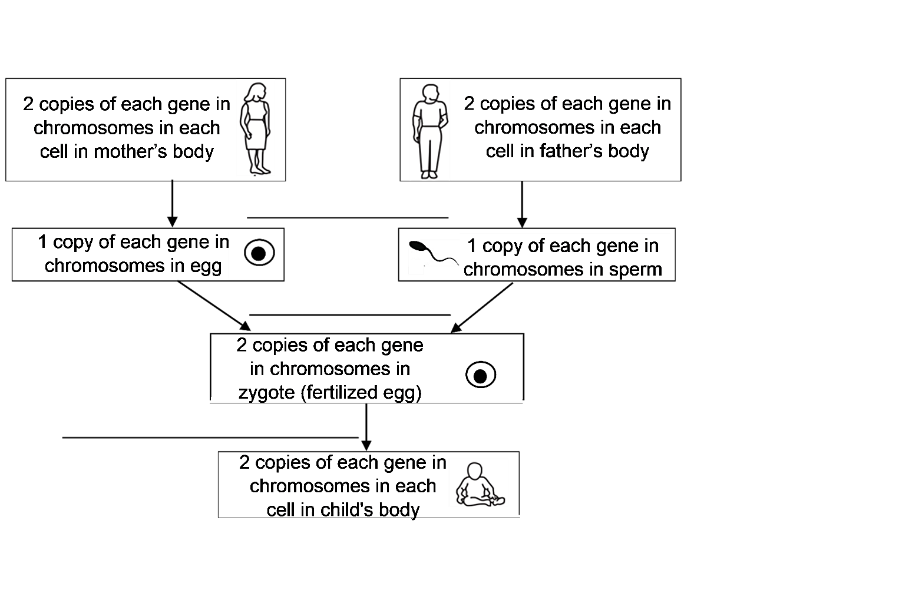

**5.** Explain how each cell in a child’s body gets one copy of each gene from each parent.

**How Inheritance of Genes can Result in Family Similarities and Differences**

To begin, we will focus on these two questions for parents who are both heterozygous **Aa**.

* What combinations of **A** and/or **a** alleles could their children have?
* Will the children have the same characteristic as their parents?

In this figure, the top circle shows a pair of chromosomes in a cell that is beginning meiosis in a

|  |  |  |
| --- | --- | --- |
| heterozygous **Aa** father. Each chromosome has two sister chromatids. (Although only one gene is labeled, each chromosome has many genes.)  **6a.** Complete this figure to show how the chromosomes and sister chromatids separate during meiosis.  **6b.** Label the row of circles that represent sperm.  **6c.** What is the genetic makeup of the different types of sperm that an **Aa** father can produce? _**A**_ or ____  **6d.** What is the genetic makeup of the different types of eggs that an **Aa** mother can produce? ____ or ____ | |  |
| **7a.** This figure showsfertilization of each different type of egg by each different type of sperm. To show the outcomes of fertilization, label the allele (**A** or **a**) for each chromosome in each zygote (fertilized egg).  **7b.** Circle the combination of egg and sperm that will produce an **AA** zygote.  **7c.** Both parents are heterozygous **Aa**, so neither parent would be albino. However, they could have an albino child. Put a square around the zygote that would develop into an albino child. |  | |

|  |  |
| --- | --- |
| This chart combines the results of meiosis and fertilization for an **Aa** mother and an **Aa** father. It shows the genetic makeup of the different zygotes that meiosis and fertilization could produce.  **8a**. Label the arrows that represent meiosis.  **8b.** Circle the part of this chart that shows how meiosis and fertilization could produce an **AA** zygote. |  |

|  |  |  |  |  |
| --- | --- | --- | --- | --- |
| Biologists use a similar chart to analyze inheritance. However, biologists omit much of the detail and use a simplified version called a **Punnett Square**. | **A**  **a** | **A** | **a** |  |
| **AA** | **Aa** |  |
| **Aa** | **aa** |  |

**9a.** The pair of letters in each rectangle in the Punnett square is interpreted as the genotype of a child that these heterozygous **Aa** parents could produce. This contrasts with the previous chart where the same pairs of letters were interpreted as the genotypes of zygotes. Explain why the genotype would be the same for a child and the zygote that the child developed from.

**9b.** Circle the part of the Punnett square that shows that these two heterozygous **Aa** parents could have a child with the **AA** genotype.

**10.** Explain how two heterozygous **Aa** parents could have a child who has a different characteristic that neither parent has.

|  |  |
| --- | --- |
| **11a.** To further investigate how genes contribute to the similarities between parents and their children, draw a Punnett square for two albino parents. |  |

**11b.** Explain why two albino parents will have only albino children.

**12a.** The genotype of a parent who is *not* albino is ______ or ______. Complete a Punnett square for each possible combination of these parental genotypes.

|  |  |  |  |  |  |  |  |  |  |  |  |
| --- | --- | --- | --- | --- | --- | --- | --- | --- | --- | --- | --- |
|  | | | |  | | | |  | | | |
|  |  |  |  |  |  |  |  |  |  |  |  |
|  |  |  |  |  |  |  |  |
|  | | | |  | | | |  | | | |

**12b.** For these Punnett squares, both parents are *not* albino. Circle the genotypes of each possible child who would have the same characteristic as both parents.

**13.** Explain how genes contribute to the generally similar appearance of family members. (Hint: A complete answer will include the words: meiosis, fertilization, alleles, gene, and protein.)

**14a.** On average, what proportion of the children of two heterozygous **Aa** parents will be albino? (Assume that each of the four possible outcomes of meiosis and fertilization is equally likely.) none of them ___ 1/4 ___ 1/2 ___ 3/4 ___ all of them ___

**14b.** Based on the number of albino people you have ever seen, what is the genetic makeup of most parents? **AA** ___ **Aa** ___ **aa** ___

In this pedigree chart, the squares represent males and the circles represent females. The solid

|  |  |
| --- | --- |
| black squares or circles represent people who are albino; everyone else is *not* albino.  **15a.** In the pedigree chart, give the genotype of each albino person and each of the Parents. |  |

**15b**. Give a genetic explanation for why the second grandchild does not look like either of her parents, but instead looks like two of her grandparents.

**16.** Can the two alleles of this gene be the cause of all the different skin colors that different people have? yes ___ no ___ Explain your reasoning.

**Family Similarities and Differences for Characteristics that are Influenced by Multiple Genes**

|  |  |
| --- | --- |
| The many different skin colors that people inherit are caused by multiple alleles of multiple genes.  Adult height is another characteristic that is highly variable and influenced by multiple alleles of multiple genes. To begin our analysis of the genetics of height, we will consider the **G** gene, which affects the cells in the growth plates of leg bones. These growth plate cells make new bone, which increases the length of leg bones, which increases height. |  |

**17.** Complete the flowchart below to show how different alleles of the **G** gene result in different adult heights.

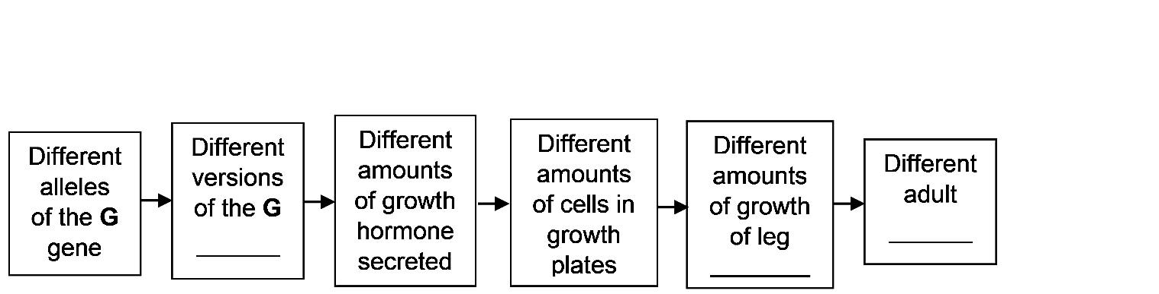

|  |  |  |
| --- | --- | --- |
| This table shows the effects of two alleles of the **G** gene; these effects are added to the effects of the multiple other genes that influence height. Notice that the effect on height of the heterozygous **G0G1** genotype is | **Genotype** | **Effect on Adult Height** |
| **G0G0** | 0 |
| **G0G1** | + 1 cm |
| **G1G1** | + 2 cm |

intermediate between the effects on height of the **G0G0** and **G1G1** genotypes This is an example of **incomplete dominance**.

**18a.** Complete each Punnett square.

|  |  |  |  |  |  |  |  |  |  |  |  |
| --- | --- | --- | --- | --- | --- | --- | --- | --- | --- | --- | --- |
| 2 **G0G0** parents | | | | 2 **G0G1** parents | | | | 2 **G1G1** parents | | | |
|  | | | |  | | | |  | | | |
|  |  |  |  |  |  |  |  |  |  |  |  |
|  |  |  |  |  |  |  |  |
|  | | | |  | | | |  | | | |

**18b.** How does the G gene help to explain why taller parents tend to have taller children?

**18c.** Explain how two adult brothers who have the same biological mother and father could have different heights.

This flowchart shows two of the genes that affect adult height. This flowchart also shows that dozens of additional genes, plus an environmental factor, influence adult height. Most alleles of these genes have small effects on adult height.

**19.** Based on the above information, why are there so many different adult heights?

**20**. Explain how the SRY gene can result in different adult heights for different children of the same parents.

The flowchart below outlines the genetic reasons for similarities and differences in adult height of family members.

|  |
| --- |
|  |

**21.** Summarize how genes contribute to similarities in adult height of family members. A complete answer will include explanations of how genes are inherited (represented by the thin black arrows) and how genes influence adult height (represented by the thicker gray arrows).

**Review**

**22.** How do different alleles of a gene result in different characteristics? Describe the general process, and give an example.

**23.** Choose the best match for each item in the top list.

Dominant allele ___

Recessive allele ___

Incomplete dominance ___

1. A heterozygous person has intermediate characteristics between the two different types of homozygous people.
2. A homozygous person has the same characteristic as a heterozygous person.
3. Does not affect the characteristics of the heterozygous person.

**24a.** How does a child get one copy of each gene from each parent in each cell in his/her body?

**24b.** What do the two letters in a genotype represent?

**25.** How can genes result in similar characteristics for members of the same family? Describe the general process, and give an example.

**26.** How can genes result in different characteristics for family members? Describe the general process, and give an example.

**27.** Fill in the blanks with: alleles, environmental factors, genes, or Punnett square.

A ­­­­­­­­­­­­­­­­­­­­­____________________________ is a way of summarizing the outcomes of meiosis and fertilization for two parents with known genotypes.

Height is influenced by multiple ­­_____________ of multiple ­­______________, plus

­­­­­­­­­­­­­__________________________ such as early nutrition. Many of our characteristics have similar complex genetic and environmental causes.

1. By Drs. Ingrid Waldron and Scott Poethig, Dept Biology, Univ Pennsylvania, © 2025. This Student Handout (including a Google Docs version) and Teacher Notes (with background biology and instructional suggestions) are available at <https://serendipstudio.org/exchange/bioactivities/geneticsFR>.